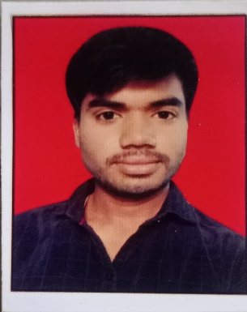

Hukam Singh Saini

[hukamsaini43644@gmail.com](mailto:hukamsaini43644@gmail.com)

mob. 6377416635

Address. Shiv Colony Suroth,Karauli

|  |
| --- |
| **Brief Overview/ Career Objective/Summary** |
| **Web development in MERN Stack. Computer Science Student with hands-on experience in web development.** |

|  |
| --- |
| **Key Expertise/Skills** |
| **HTML, CSS, Tailwind, Bootstrap, JavaScript, ReactJS, C/C++ Programming, Git, GitHub, VS Code,ExpressJS, NodeJS,MongoDB** |

|  |
| --- |
| **Education-B.TECH, XII, X- College/School name, Passing Year & Percentage** |
| **Bachelor of Science in Computer Science Engineering**  **2025College of Technology and Engineering, Udaipur | 6.9(Till 5th semester)**  **12th Class Board in RBSE | 93%**  **Indira Gandhi Senior Secondary School,Suroth 2019**  **10th Class Board in RBSE | 92.67% 2017 Indira Gandhi Senior Secondary School,Suroth** |

|  |
| --- |
| **Projects** |
| **Real Time Chatting Site: We can chat in Real Time using Socket io.**  **https://chat-app-fun.onrender.com/**  **NPM Package: Create a npm package which convert one currency to another.**  **hukam-currency-converter.**  **Shoping site: shoping site where we add items in card using map in reactJS.**  **Dice Game, DrumKit** |

|  |
| --- |
| **Assessments/Certifications** |
| **Full Stack Web Development in MERN Stack by Udemy.** |

Seminar/Training/Workshops

**Online Udemy June 2023 - July 2023**

|  |
| --- |
| **Personal Interests/Hobbies** |
| **In my free time, I can enhance my coding skills and explore other study materials.** |

|  |
| --- |
| **Personal Details** |
| **Date of Birth : 16-02-2002 Marital Status : Single Nationality : India**  **Religion : Hindu Gneder : Male**  **Place : Rajasthan** |

DECLARATION:

I hereby declare that the details provided by me in this resume are correct and I have knowingly not omitted/ misrepresented any information.

Date: 30/8/2024

Signature:

